Problem 4:

1. Canada:

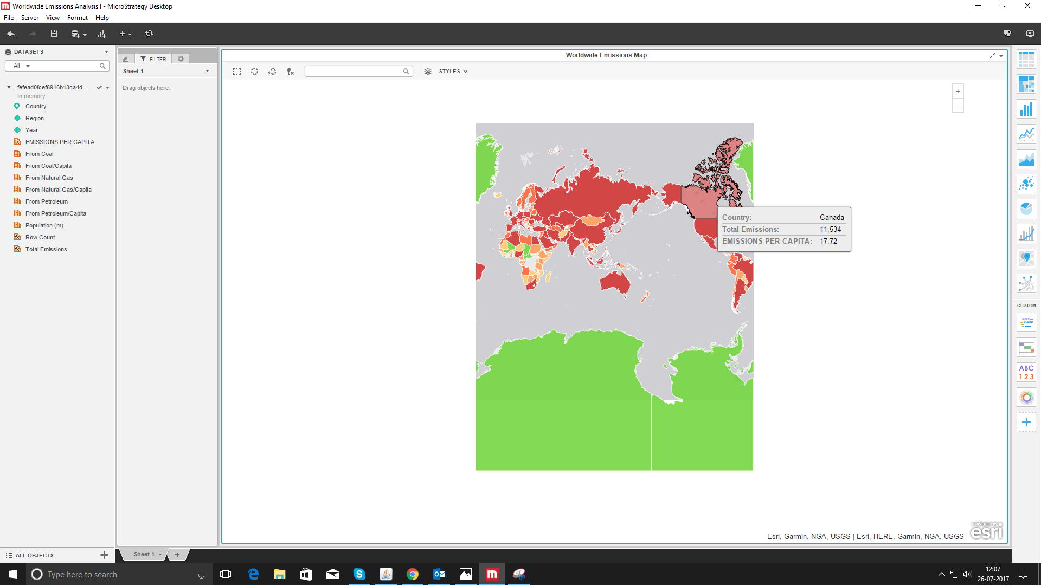

1. The emission has increase so fast in the last decade between 2003 and 2006.However, from 2009 there was a decrease in usage of Natural Gas and Petroleum

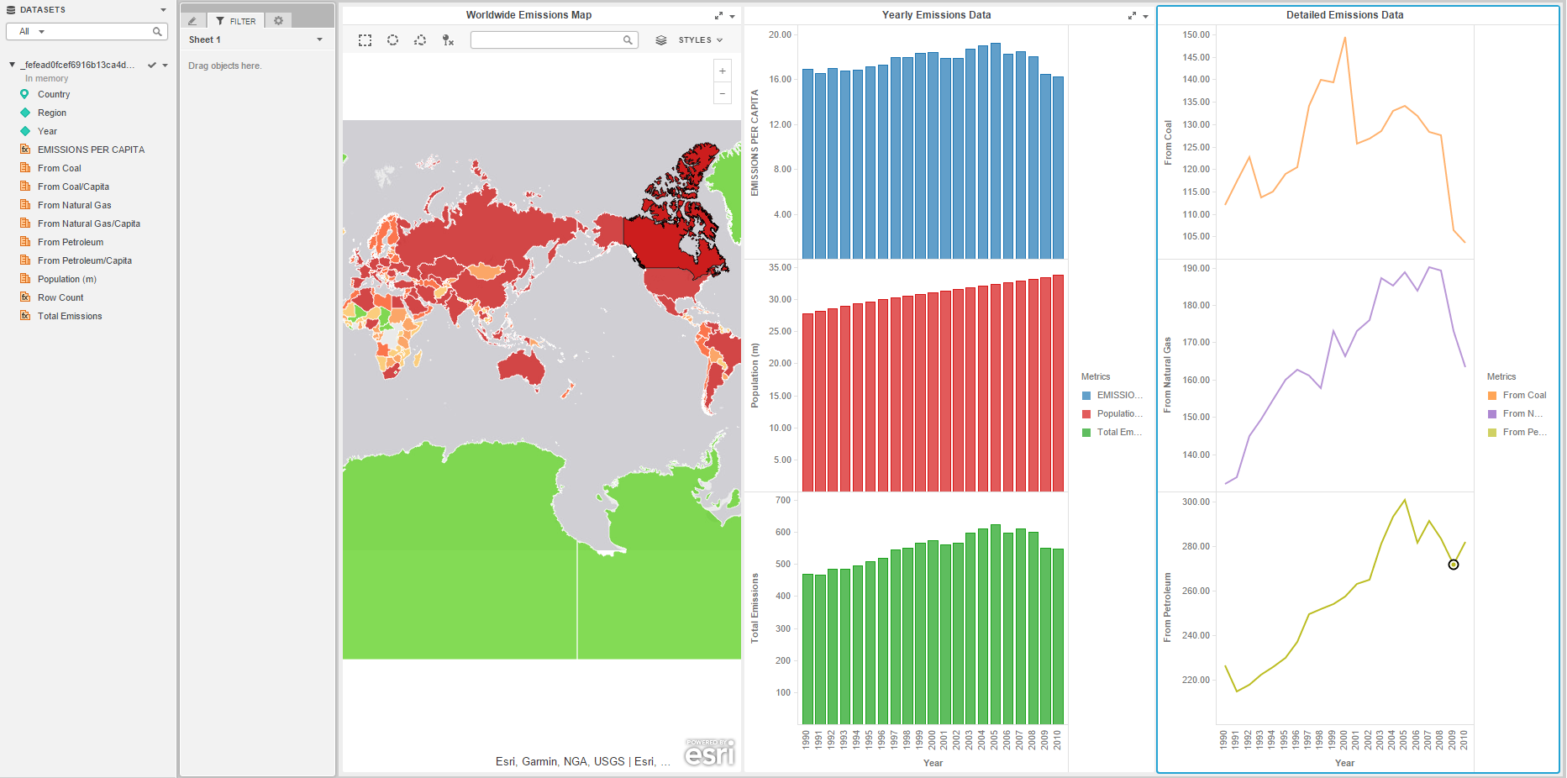

1. There is a big chance of decline which is related to the 2008 crisis and it has affected lives of millions of people, changing their habits of consumption in the biggest economy of the world.

